**Scenario**

* Your organization is running your application workloads on AWS, The architecture of your application is as follows 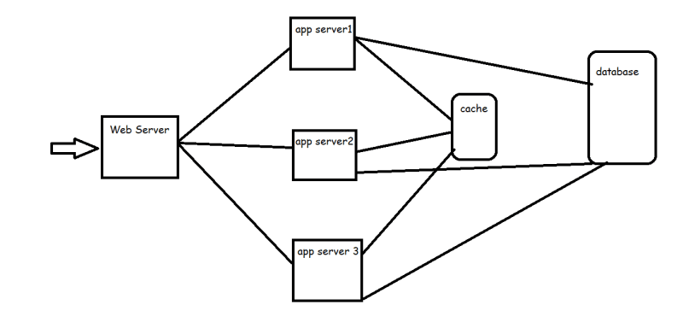
* To deploy this on AWS, the solution architect has proposed the following solution for your application 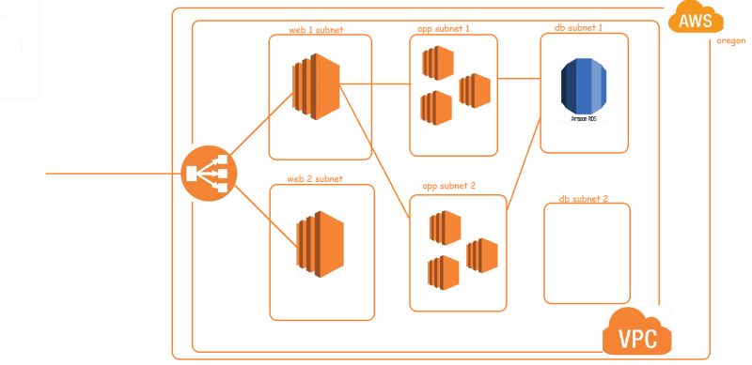
* So, when it comes to operations w.r.t creation/maintenance, we need to understand our responsibilities
* Shared Responsibility Model:

To understand shared responsibility lets look at cloud pyramid 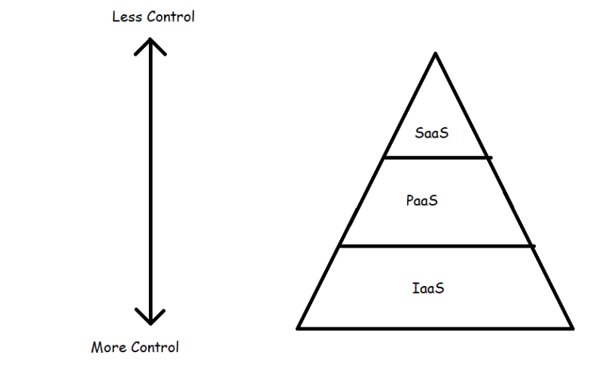

* IAAS vs PAAS vs SAAS 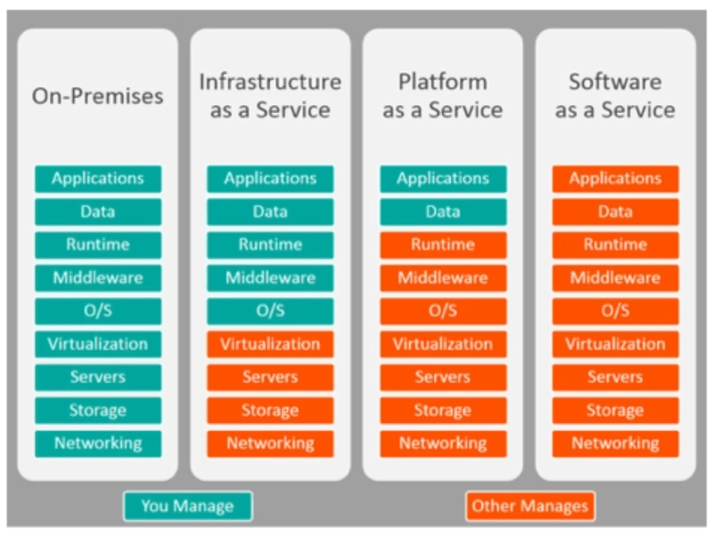

Let’s understand our expected tasks as Cloud Engineer from Operations perspective

* Lots of AWS Deployments of Enterprise Grade Applications, still use Virtual Machines (EC2 Instances)
  + Patching
* When we want to manage any resource, we need to monitor it and alert in case of any errors
* We need to have to maintain audit trail of the changes in our resources
* Policy Management, Implement and reporting on any issues.
* Business Continuity and Disaster Recovery (BCDR)